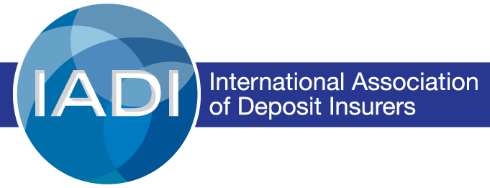

Expression of Interest
To participate in the Pilot Test of the Core Principles Practitioners Workshop in Basel

The Core Principles Practitioners Workshop represents the first step in a four-step structured and standardized training program as prescribed by the Expert Training Strategy. Participants in this workshop will gain a thorough understanding of the development and purpose of the Core Principles (CPs) and their Essential Criteria. Participants are expected to become the source of information about the CPs for their agencies, capable of conducting a self-assessment of compliance with the CPs and be able to provide support to regional IADI training events.
For those Members interested in continuing their training and becoming a CP Expert or a Lead CP Expert under the Experts Training Strategy, this workshop is a prerequisite.

Minimum Requirements:

- The participant must be staff of an IADI Member.
- Participants are expected to have a minimum of two years of relevant work experience, good knowledge about deposit insurance matters (via participating in a self-assessment process, completing the relevant FSI Connect tutorials, or other relevant experience) and an interest in deepening their knowledge of the CPs and the elements used to evaluate compliance with the CPs.
- The participant must be a mid-level to senior official in their deposit insurance agency.
- The participant must have approval or support from their deposit insurance agency.

If you are interested in participating in this workshop and meet the criteria above, please complete the following sections.

- Please provide your personal details in the table below.

Name | Surname | Title | Jurisdiction | Email Address

- Do you plan to continue with the rest of the Expert Training Program to become a Lead CP Expert (Expert Training Working Group, Expert Workshop and participating in at least two Self Assessment Technical Assistance Programme) or are you only interested in the Practitioners Workshop?
…………………………………………………………………………………………………………………………………………………..

- Please indicate that you have support from your organisation to attend this workshop to be held in Basel from 25 – 29 July 2022.
………………………………………………………………………………………………………………………………………………….

- Please attach your CV or list your experience with the IADI Core Principles here.
…………………………………………………………………………………………………………………………………………………..

The workshop accommodates a limited number of participants to ensure effective participation and engagement. In addition, we must comply with BIS restrictions currently in place for live events.

Please return this form no later than cob 6 June 2022 to Eugenia.Alamillo@iadi.org, asinopole@fdic.gov and Karen.Gibbons@fscs.org.uk and cc Taurai.Togarepi@iadi.org, ryoussef@FDIC.gov, egarnett@fdic.gov and kbinder@fdic.gov.

A participant in the Expert Training Programme would be designated as a CP Expert, capable of serving on SATAP review teams, after completing the third of four stages – the CP Expert Workshop. If a CP Expert were to serve on two SATAP reviews, they could be designated as a Lead CP Expert if approved by the current list of Lead CP Experts.

